**Chapter-3**

**Purpose**: To carry out the activities of writing actual programmes, their debugging, testing and validation. Following activities are to be carried out:

**Programme Development:**

**Tech Used:**

|  |  |
| --- | --- |
| **Front-End** | HTML, CSS, JavaScript |
| **Back-End** | Express JS, Node JS |
| **Frameworks** | jQuery, React JS, Bootstrap |
| **Database** | Mongo DB |
| **Software** | VS Code |
| **Operating System** | Windows OS |

**GUI Screens:**

**Career Roadmaps Homepage with Heading Navbar Menu**

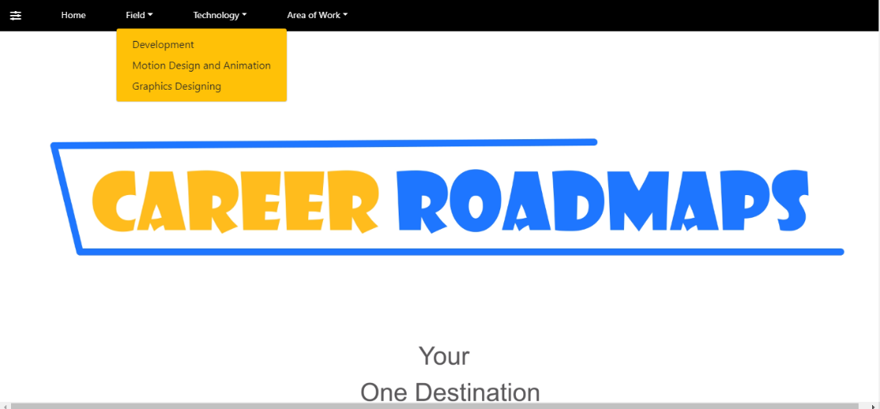

**Career Roadmaps Homepage with Bottom Collapsed Menu**

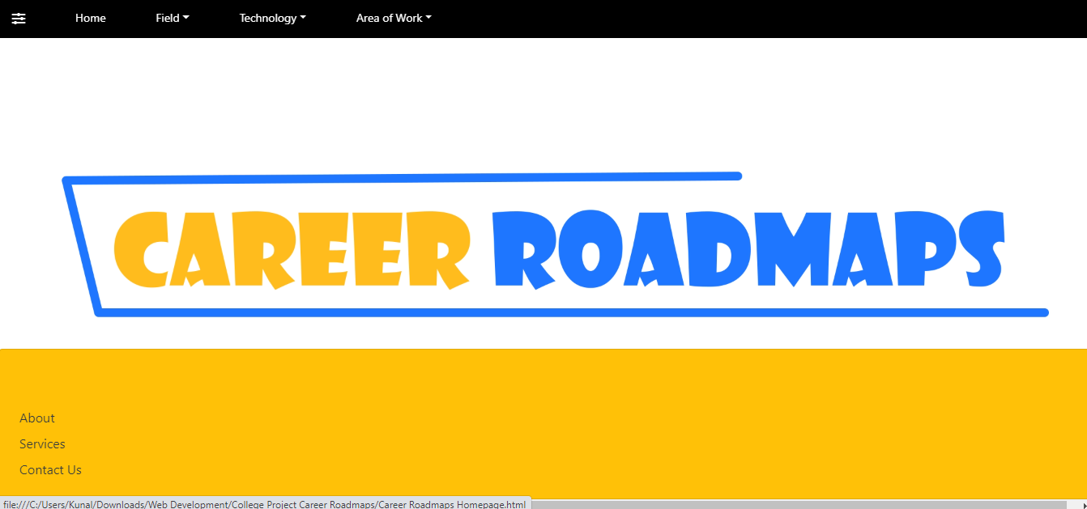

**Career Roadmaps About Us Section**



**Career Roadmaps Contact Us section**

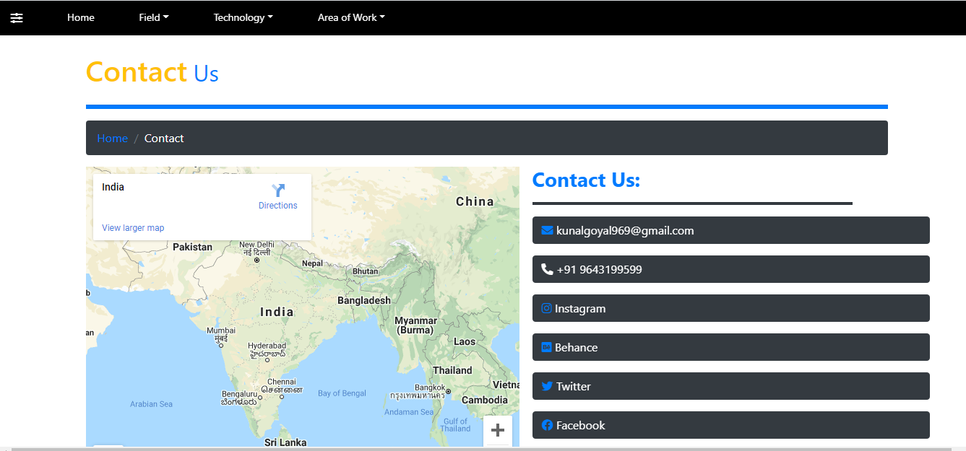

**Career Roadmaps Login section**

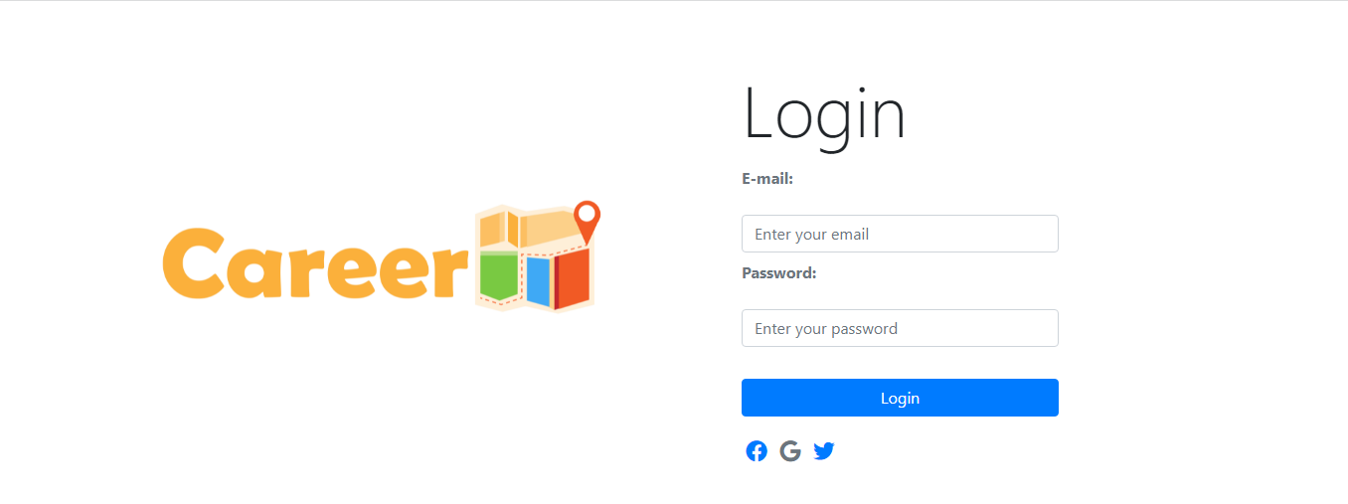

**Career Roadmaps Sign Up section**

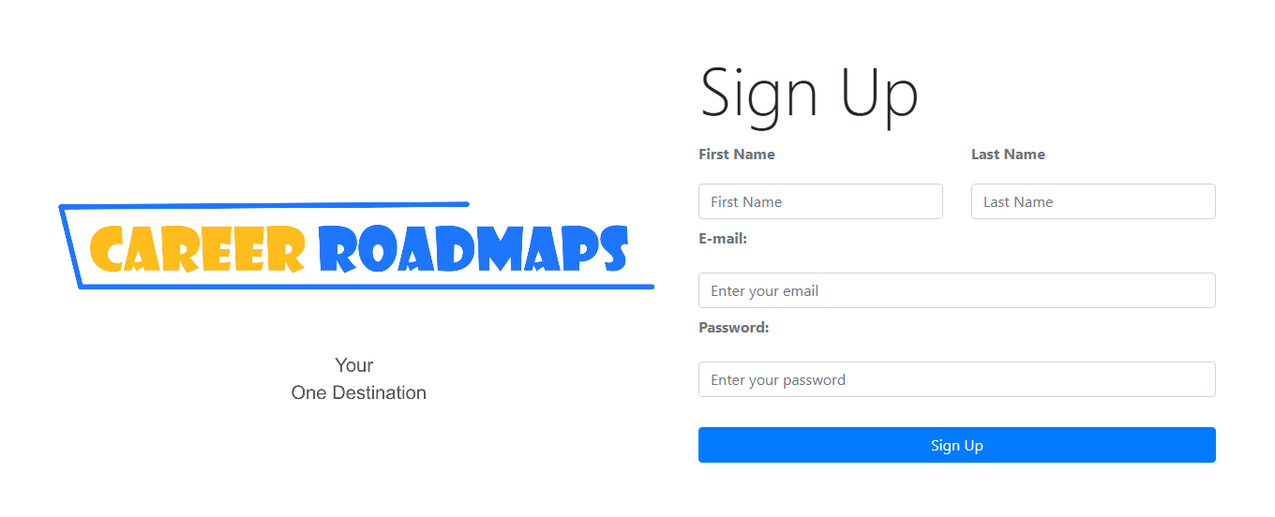

**Career Roadmaps Web Development section**

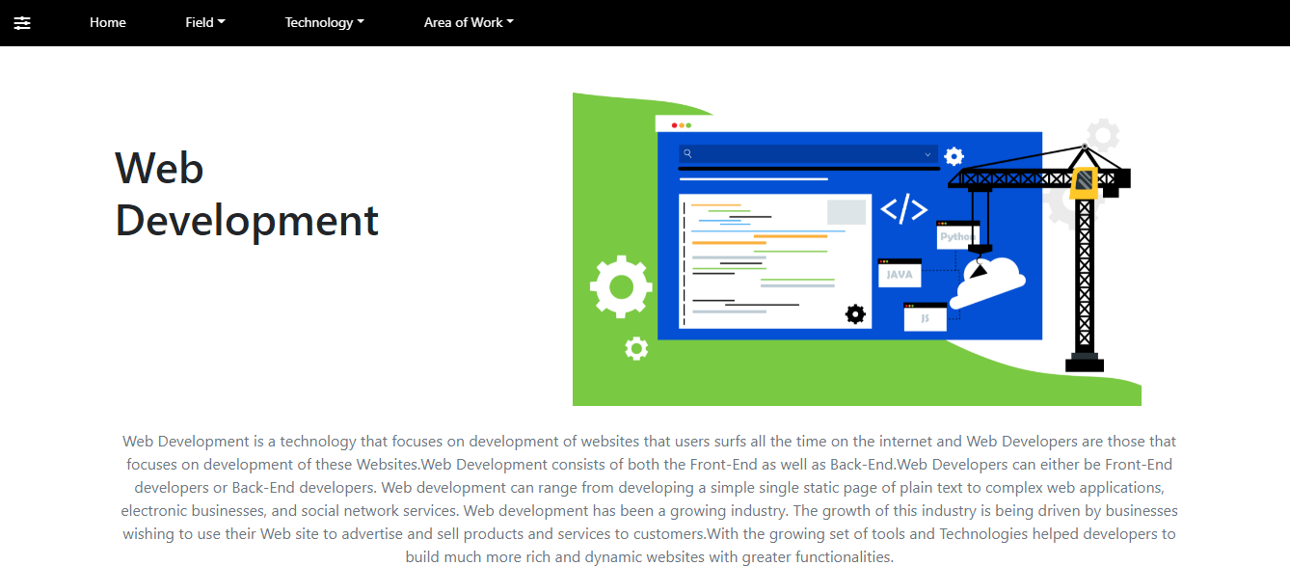

**Career Roadmaps App Development section**

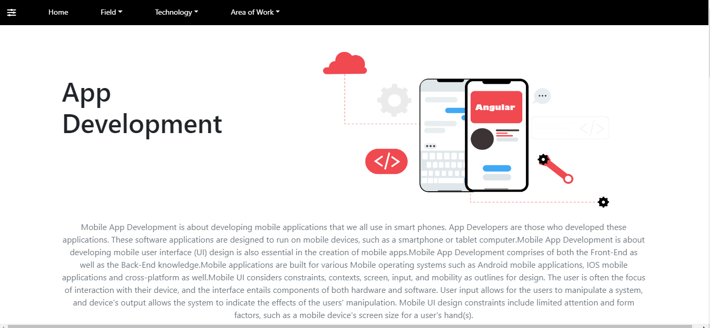

**Career Roadmaps Full Stack section**

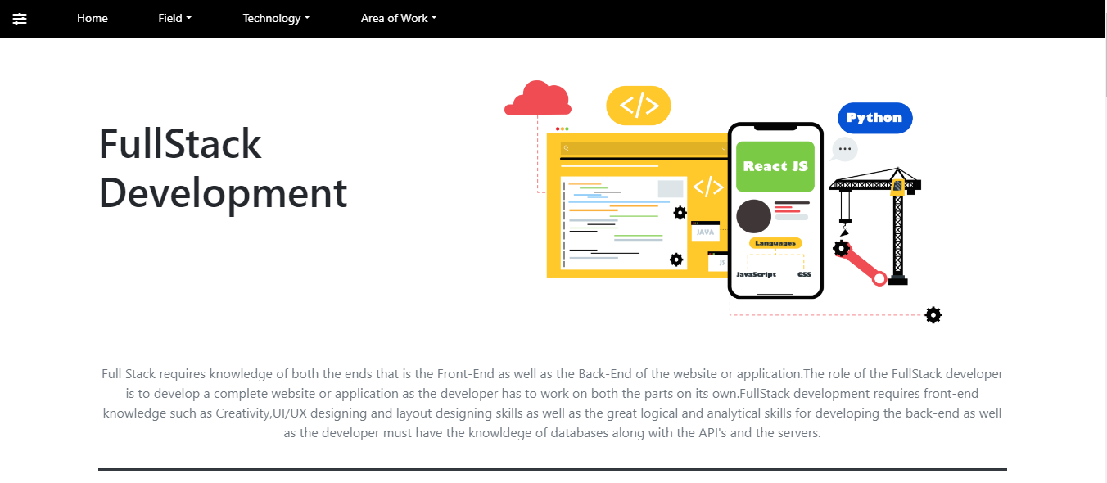

**Programme Codes:**

<!DOCTYPE html>

<html>

<head>

<title>Career Roadmaps Home Page</title>

<!-- Bootstrap core CSS -->

<link rel="stylesheet" href="https://stackpath.bootstrapcdn.com/bootstrap/4.3.1/css/bootstrap.min.css"

integrity="sha384-ggOyR0iXCbMQv3Xipma34MD+dH/1fQ784/j6cY/iJTQUOhcWr7x9JvoRxT2MZw1T" crossorigin="anonymous">

<link rel="stylesheet" href="https://pro.fontawesome.com/releases/v5.10.0/css/all.css"

integrity="sha384-AYmEC3Yw5cVb3ZcuHtOA93w35dYTsvhLPVnYs9eStHfGJvOvKxVfELGroGkvsg+p" crossorigin="anonymous" />

<meta name="viewport" content="width=device-width, initial-scale=1.0">

<style>

#my1 {

position: absolute;

left: 1px;

}

#my2 {

position: absolute;

left: 100px;

}

#my3 {

position: absolute;

right: 1050px;

}

#my4 {

position: absolute;

right: 900px;

}

#my5 {

position: absolute;

right: 750px;

}

</style>

</head>

<body>

<div class="nav nav-fill fixed-top" style="background-color: black;">

<div class="row">

<div class="col-sm">

<div class="nav-item">

<a href="" class="nav-link mt-1" style="font-size: medium;" data-toggle="collapse"

data-target="#contact1"><i class="fas fa-sliders-h text-white"></i></a>

</div>

</div>

<div class="col">

<li class="nav-item">

<a href="Career Roadmaps Homepage.html" class="nav-link btn text-white border-0 mt-1" type="button"

style="font-size:14px;background-color: black;">Home</a>

</li>

</div>

<div class="col-sm">

<div class="nav-item">

<div class="dropdown">

<a class="text-white btn border-0 nav-link dropdown-toggle mt-1" type="button"

data-toggle="dropdown" style="font-size:14px;background-color: black;">Field</a>

<div class="dropdown-menu bg-warning">

<a href="Development page.html" class="dropdown-item">Development</a>

<a href="Motion Design or Animation Pagre.html" class="dropdown-item">Motion Design and

Animation</a>

<a href="Coming soon page.html" class="dropdown-item">Graphics Designing</a>

</div>

</div>

</div>

</div>

<div class="col-sm">

<div class="nav-item">

<div class="dropdown">

<a class="btn btn-dark text-white nav-link dropdown-toggle border-0 mt-1" type="button"

data-toggle="dropdown" style="font-size:14px;background-color: black;">Technology</a>

<div class="dropdown-menu bg-warning">

<a href="Web development Page.html" class="dropdown-item">Web Development</a>

<a href="App development Page.html" class="dropdown-item">App Development</a>

<a href="Full stack development Page.html" class="dropdown-item">Full Stack Development</a>

<a href="Front end development page.html" class="dropdown-item">Front-End Development</a>

<a href="back-end development page.html" class="dropdown-item">Back-End Development</a>

<a href="Coming soon page.html" class="dropdown-item">Software Development</a>

<a href="Coming soon page.html" class="dropdown-item">Game Development</a>

<a href="Coming soon page.html" class="dropdown-item">Data Scientist</a>

<a href="Coming soon page.html" class="dropdown-item">Software Testing</a>

<a href="Coming soon page.html" class="dropdown-item">Designing</a>

<a href="Coming soon page.html" class="dropdown-item">Motion Designing</a>

<a href="Coming soon page.html" class="dropdown-item">Traditional Animation</a>

<a href="Coming soon page.html" class="dropdown-item">Animation</a>

<a href="Coming soon page.html" class="dropdown-item">Stop Motion</a>

</div>

</div>

</div>

</div>

<div class="col-sm">

<div class="nav-item">

<div class="dropdown">

<a class="btn btn-dark text-white nav-link dropdown-toggle border-0 mt-1" type="button"

data-toggle="dropdown" style="font-size:14px;background-color: black;">Area of Work</a>

<div class="dropdown-menu bg-warning">

<a href="Front end development page.html" class="dropdown-item">Front-End Development</a>

<a href="back-end development page.html" class="dropdown-item">Back-End Development</a>

<a href="Coming soon page.html" class="dropdown-item">Manual Testing</a>

<a href="Coming soon page.html" class="dropdown-item">Automation Testing</a>

<a href="Coming soon page.html" class="dropdown-item">Animation</a>

<a href="Coming soon page.html" class="dropdown-item">Illustration</a>

<a href="Coming soon page.html" class="dropdown-item">UI/UX Designing</a>

<a href="Coming soon page.html" class="dropdown-item">2D Animation</a>

<a href="Coming soon page.html" class="dropdown-item">3D Animation</a>

</div>

</div>

</div>

</div>

</div>

<br>

<br>

</div>

<div class="collapse fixed-bottom" id="contact1">

<div class="card card-body bg-warning">

<br>

<br>

<a href="about.html" class="text-dark m-1">About</a>

<a href="services.html" class="text-dark m-1">Services</a>

<a href="contact us.html" class="text-dark m-1">Contact Us</a>

</div>

</div>

<div class="row">

<div class="col-sm-12">

<video height="720px" width="1280px" autoplay muted loop class="ml-5 mb-5">

<source src="C:\Users\Kunal\Downloads\Web Development\College Project Career Roadmaps\Cr.mp4"

type="video/mp4">

</video>

</div>

</div>

<div class="container">

<div class="row">

<div class="col-sm-4">

<br>

<br>

<br>

<br>

<h1 class="text-primary">What is a Roadmap?</h1>

<p class="text-muted">A Roadmap is a visual flowchart or any other visual representation of data that

helps one to get all the information required to move towards the right direction of the chosen

technology. </p>

</div>

<div class="col-md-4">

<video autoplay muted loop height="450px" width="720px">

<source

src="C:\Users\Kunal\Downloads\Web Development\College Project Career Roadmaps\career roadmaps 2.mp4"

type="video/mp4">

</video>

</div>

</div>

</div>

<div class="container">

<center>

<h1 class="text-primary">What is Career Roadmaps?</h1>

</center>

<hr class="bg-warning" style="height: 01px;">

<div class="row">

<div class="col-sm-10">

<p class="text-muted">Career Roadmaps will help everyone to set the right path to achieve their goals

and success by choosing a right technology. Career Roadmaps will provide complete roadmaps about

every technology and covers every important aspect what is right for you. Career Roadmaps is not

just limited to people belonging to technical background but as well as it will help everyone

whether you belong to artist background or designing background or any other aspect.

</p>

</div>

</div>

<center>

<h1 class="text-primary">Fields</h1>

</center>

<hr class="bg-warning" style="height: 01px;">

<div class="row">

<div class="col-sm-5">

<br>

<br>

<h1 class="text-dark">Development</h1>

<p class="text-muted">In the Field of Development our Roadmaps will guide you Step by Step about how to

move towards the right direction</p>

<a href="Development page.html" class="btn btn-primary">Development</a>

</div>

<div class="col-sm-5">

<img src="Development Design.jpg" style="height: 325px;width: 590px;">

</div>

</div>

<br>

<div class="row">

<div class="col-sm-5">

<br><br>

<h1 class="text-dark">Motion Design and Animation</h1>

<p class="text-muted">In the Field of Motion Design our Roadmaps will guide you Step by Step about how

to move towards the right direction</p>

<a href="Motion Design or Animation Pagre.html" class="btn btn-primary">Motion Design or Animation</a>

</div>

<div class="col-sm-6">

<video autoplay muted loop height="450px" width="720px">

<source

src="C:\Users\Kunal\Downloads\Web Development\College Project Career Roadmaps\car animation.mp4"

type="video/mp4">

</video>

</div>

</div>

<br>

<div class="row" onmouseover="func1()" onmouseout="func2()">

<div class="col-sm-5">

<br><br>

<h1 class="text-dark">Graphics Designing</h1>

<p class="text-muted">In the Field of Graphics Designing our Roadmaps will guide you Step by Step about

how to move towards the right direction</p>

<a href="#" class="btn btn-primary">Graphics Designing</a>

</div>

<div class="col-sm-5">

<img id="img1" src="E:\Adobe\Ai2\halloween theme 1 white.jpg" style="height: 350px;width: 600px;">

</div>

</div>

<br>

<br>

</div>

<div class="row justify-content-center">

<div class="col-lg-12">

<div class="p-5" style="background-color:whitesmoke;">

<h4 class="text-center text-muted">Website Developed by Kunal Goyal</h4>

<hr style="width: 90%">

<div class="row">

<div class="col-6">

<p class="h6 text-muted" style="font-size:smaller;">Copyright © 2021 Career Roadmaps Inc. All

rights reserved</p><br>

<a href="about.html" class="h6 text-muted" style="font-size:smaller;">About</a>

<a href="services.html" class="h6 text-muted" style="font-size:smaller;">Services</a>

<a href="contact us.html" class="h6 text-muted" style="font-size:smaller;">Contact us</a><br>

<a href="https://www.instagram.com/its_kunaaaalll/"><i

class="fab fa-instagram text-muted "></i></a> &nbsp

<a href="https://www.behance.net/kunalgoyal1?isa0=1"><i

class="fab fa-behance-square text-muted"></i></i></a> &nbsp

<a href="https://twitter.com/Kunal17271613"><i class="fab fa-twitter text-muted"></i></i></a>

&nbsp

<a href="https://www.facebook.com/kunal.goyal.31521"><i

class="fab fa-facebook text-muted"></i></i></a> &nbsp

</div>

<div class="col-2">

<p class="h6" style="font-size:smaller;">Fields</p>

<a href="Development page.html" class="h6 text-muted"

style="font-size:smaller;">Development</a><br>

<a href="Motion Design or Animation Pagre.html" class="h6 text-muted"

style="font-size:smaller;">Motion Design</a><br>

<a href="Coming soon page.html" class="h6 text-muted" style="font-size:smaller;">Graphics

Designing</a>

</div>

<div class="col-2">

<p class="h6" style="font-size:smaller;">Technology</p>

<a href="Web development Page.html" class="h6 text-muted" style="font-size:smaller;">Web

Development</a><br>

<a href="App development Page.html" class="h6 text-muted" style="font-size:smaller;">App

Development</a><br>

<a href="Full stack development Page.html" class="h6 text-muted" style="font-size:smaller;">Full

Stack Development</a><br>

<a href="Front end development page.html" class="h6 text-muted"

style="font-size:smaller;">Front-End Development</a><br>

<a href="back-end development page.html" class="h6 text-muted"

style="font-size:smaller;">Back-End Development</a><br>

<a href="Coming soon page.html" class="h6 text-muted" style="font-size:smaller;">Software

Development</a><br>

<a href="Coming soon page.html" class="h6 text-muted" style="font-size:smaller;">Game

Development</a><br>

<a href="Coming soon page.html" class="h6 text-muted" style="font-size:smaller;">Wordpress

Development</a><br>

<a href="Coming soon page.html" class="h6 text-muted" style="font-size:smaller;">Data

Scientist</a><br>

<a href="Coming soon page.html" class="h6 text-muted" style="font-size:smaller;">Software

Testing</a><br>

<a href="Coming soon page.html" class="h6 text-muted"

style="font-size:smaller;">Designing</a><br>

<a href="Coming soon page.html" class="h6 text-muted" style="font-size:smaller;">Motion

Designing</a><br>

<a href="Coming soon page.html" class="h6 text-muted" style="font-size:smaller;">Traditional

Animation</a><br>

<a href="Coming soon page.html" class="h6 text-muted"

style="font-size:smaller;">Animation</a><br>

<a href="Coming soon page.html" class="h6 text-muted" style="font-size:smaller;">Stop

Motion</a><br>

</div>

<div class="col-2">

<p class="h6" style="font-size:smaller;">Area of Work</p>

<a href="Front end development page.html" class="h6 text-muted"

style="font-size:smaller;">Front-End Development</a><br>

<a href="back-end development page.html" class="h6 text-muted"

style="font-size:smaller;">Back-End Development</a><br>

<a href="Coming soon page.html" class="h6 text-muted" style="font-size:smaller;">Manual

Testing</a><br>

<a href="Coming soon page.html" class="h6 text-muted" style="font-size:smaller;">Automation

Testing</a><br>

<a href="Coming soon page.html" class="h6 text-muted"

style="font-size:smaller;">Illustration</a><br>

<a href="Coming soon page.html" class="h6 text-muted" style="font-size:smaller;">UI/UX

Designing</a><br>

<a href="Coming soon page.html" class="h6 text-muted" style="font-size:smaller;">2D

Animation</a><br>

<a href="Coming soon page.html" class="h6 text-muted" style="font-size:smaller;">3D

Animation</a>

</div>

</div>

</div>

</div>

</div>

</div>

<script>

function func1() {

document.getElementById("img1").src = "halloween theme 1 dark coming soon.jpg";

}

function func2() {

document.getElementById("img1").src = "halloween theme 1 white.jpg";

}

</script>

<!-- Bootstrap core JavaScript -->

<script src="https://code.jquery.com/jquery-3.3.1.slim.min.js"

integrity="sha384-q8i/X+965DzO0rT7abK41JStQIAqVgRVzpbzo5smXKp4YfRvH+8abtTE1Pi6jizo"

crossorigin="anonymous"></script>

<script src="https://cdnjs.cloudflare.com/ajax/libs/popper.js/1.14.7/umd/popper.min.js"

integrity="sha384-UO2eT0CpHqdSJQ6hJty5KVphtPhzWj9WO1clHTMGa3JDZwrnQq4sF86dIHNDz0W1"

crossorigin="anonymous"></script>

<script src="https://stackpath.bootstrapcdn.com/bootstrap/4.3.1/js/bootstrap.min.js"

integrity="sha384-JjSmVgyd0p3pXB1rRibZUAYoIIy6OrQ6VrjIEaFf/nJGzIxFDsf4x0xIM+B07jRM"

crossorigin="anonymous"></script>

</body>

</html>

<!DOCTYPE html>

<html>

<head>

<title>Project-Contact Page</title>

<!-- Bootstrap core CSS -->

<link rel="stylesheet" href="https://stackpath.bootstrapcdn.com/bootstrap/4.3.1/css/bootstrap.min.css"

integrity="sha384-ggOyR0iXCbMQv3Xipma34MD+dH/1fQ784/j6cY/iJTQUOhcWr7x9JvoRxT2MZw1T" crossorigin="anonymous">

<link rel="stylesheet" href="https://pro.fontawesome.com/releases/v5.10.0/css/all.css"

integrity="sha384-AYmEC3Yw5cVb3ZcuHtOA93w35dYTsvhLPVnYs9eStHfGJvOvKxVfELGroGkvsg+p" crossorigin="anonymous" />

<style>

a:active {

color: white;

}

</style>

</head>

<body>

<div class="nav nav-fill fixed-top" style="background-color: black;">

<div class="row">

<div class="col-sm">

<div class="nav-item">

<a href="" class="nav-link mt-1" style="font-size: medium;" data-toggle="collapse"

data-target="#contact1"><i class="fas fa-sliders-h text-white"></i></a>

</div>

</div>

<div class="col">

<li class="nav-item">

<a href="Career Roadmaps Homepage.html" class="nav-link btn text-white border-0 mt-1" type="button"

style="font-size:14px;background-color: black;">Home</a>

</li>

</div>

<div class="col-sm">

<div class="nav-item">

<div class="dropdown">

<a class="text-white btn border-0 nav-link dropdown-toggle mt-1" type="button"

data-toggle="dropdown" style="font-size:14px;background-color: black;">Field</a>

<div class="dropdown-menu bg-warning">

<a href="Development page.html" class="dropdown-item">Development</a>

<a href="Motion Design or Animation Pagre.html" class="dropdown-item">Motion Design and

Animation</a>

<a href="#" class="dropdown-item">Graphics Designing</a>

</div>

</div>

</div>

</div>

<div class="col-sm">

<div class="nav-item">

<div class="dropdown">

<a class="btn btn-dark text-white nav-link dropdown-toggle border-0 mt-1" type="button"

data-toggle="dropdown" style="font-size:14px;background-color: black;">Technology</a>

<div class="dropdown-menu bg-warning">

<a href="#" class="dropdown-item">Web Development</a>

<a href="#" class="dropdown-item">App Development</a>

<a href="#" class="dropdown-item">Full Stack Development</a>

<a href="#" class="dropdown-item">Front-End Development</a>

<a href="#" class="dropdown-item">Back-End Development</a>

<a href="#" class="dropdown-item">Software Development</a>

<a href="#" class="dropdown-item">Game Development</a>

<a href="#" class="dropdown-item">Data Scientist</a>

<a href="#" class="dropdown-item">App Development</a>

<a href="#" class="dropdown-item">Software Testing</a>

<a href="#" class="dropdown-item">Designing</a>

<a href="#" class="dropdown-item">Motion Designing</a>

<a href="#" class="dropdown-item">Traditional Animation</a>

<a href="#" class="dropdown-item">Animation</a>

<a href="#" class="dropdown-item">Stop Motion</a>

</div>

</div>

</div>

</div>

<div class="col-sm">

<div class="nav-item">

<div class="dropdown">

<a class="btn btn-dark text-white nav-link dropdown-toggle border-0 mt-1" type="button"

data-toggle="dropdown" style="font-size:14px;background-color: black;">Area of Work</a>

<div class="dropdown-menu bg-warning">

<a href="#" class="dropdown-item">Front-End Development</a>

<a href="#" class="dropdown-item">Back-End Development</a>

<a href="#" class="dropdown-item">Manual Testing</a>

<a href="#" class="dropdown-item">Automation Testing</a>

<a href="#" class="dropdown-item">Animation</a>

<a href="#" class="dropdown-item">Illustration</a>

<a href="#" class="dropdown-item">UI/UX Designing</a>

<a href="#" class="dropdown-item">2D Animation</a>

<a href="#" class="dropdown-item">3D Animation</a>

</div>

</div>

</div>

</div>

</div>

<br>

<br>

</div>

<div class="collapse fixed-bottom" id="contact1">

<div class="card card-body bg-warning">

<br>

<br>

<a href="about.html" class="text-dark m-1">About</a>

<a href="services.html" class="text-dark m-1">Services</a>

<a href="contact us.html" class="text-dark m-1">Contact Us</a>

</div>

</div>

<br>

<br>

<div class="container"><br>

<center>

<h1 class="text-warning mb-4 text-left">Contact<small class="text-primary ml-2">Us</small></h1>

</center>

<hr style="width:100%;height: 05px;" class="bg-primary ">

<ol class="breadcrumb bg-dark">

<li class="breadcrumb-item">

<a href="Career Roadmaps Homepage.html">Home</a>

</li>

<li class="breadcrumb-item active text-white">Contact</li>

</ol>

<div class="row">

<div class="col-lg-6 mb-4">

<iframe

src="https://www.google.com/maps/embed?pb=!1m18!1m12!1m3!1d15197891.186466021!2d70.73387665410758!3d21.569419204950094!2m3!1f0!2f0!3f0!3m2!1i1024!2i768!4f13.1!3m3!1m2!1s0x30635ff06b92b791%3A0xd78c4fa1854213a6!2sIndia!5e0!3m2!1sen!2sin!4v1626713280086!5m2!1sen!2sin"

width="600" height="450" style="border:0;" allowfullscreen="" loading="lazy"></iframe>

</div>

<div class="col-lg-6 mb-4">

<h3 class="text-primary ml-5"><b>Contact Us:</b></h3>

<hr class="bg-dark" style="height: 03px;width:82%">

<p class="ml-5"><a style="width: 550px;text-align: left"

href="https://mail.google.com/mail/u/0/?tab=rm&ogbl#inbox?compose=GTvVlcSGLPsCbHbCmxgZwxPfwptPTzZQPzzmlzDsJJbgjbbvVlzxrbqjjGHdHCCRDXtSVcxvRHcQV"

class="btn btn-dark"><i class="fas fa-envelope text-primary"></i> kunalgoyal969@gmail.com</a>

</p>

<p class="ml-5 btn btn-dark" style="width: 550px;text-align: left"><i class="fas fa-phone-alt"></i> +91

9643199599</p>

<p><a href="https://www.instagram.com/its_kunaaaalll/" class="ml-5 btn btn-dark"

style="width: 550px;text-align: left"><i class="fab fa-instagram text-primary"></i>

Instagram</a></p>

<p><a href="https://www.behance.net/kunalgoyal1?isa0=1" class="ml-5 btn btn-dark"

style="width: 550px;text-align: left"><i class="fab fa-behance-square text-primary"></i></i>

Behance</a></p>

<p><a href="https://twitter.com/Kunal17271613" class="ml-5 btn btn-dark"

style="width: 550px;text-align: left"><i class="fab fa-twitter text-primary"></i></i>

Twitter</a></p>

<p><a href="https://www.facebook.com/kunal.goyal.31521" class="ml-5 btn btn-dark"

style="width: 550px;text-align: left"><i class="fab fa-facebook text-primary "></i></i>

Facebook</a></p>

<p class="ml-5 btn btn-dark" style="width: 550px;text-align: left"><i class="fas fa-map-marked-alt"></i>

D-1 58/59 Jeevan Park,New Delhi-59</p>

<p class="ml-5 btn btn-dark" style="width: 550px;text-align: left"><i class="fas fa-clock"></i> Monday

to Friday: 9AM to 6PM</p>

</div>

<div class="col-lg-6 mb-4">

<h2>Send us a Message</h2>

<form id="re" onsubmit="return call()">

<label for="name" type="form-control">Name:</label>

<input type="text" placeholder="Enter your Name" class="form-control" name="name" id="name"

autocomplete="off">

<span id="name2" class="text-danger"></span><br>

<label for="email" type="form-control">Email:</label>

<input type="text" placeholder="Enter your Email" class="form-control" name="email" id="email"

autocomplete="off">

<span id="email2" class="text-danger"></span><br>

<label for="contact" type="form-control">Contact:</label>

<input type="text" placeholder="Enter your Number" class="form-control" name="contact" id="contact"

autocomplete="off">

<span id="contact2" class="text-danger"></span><br>

<label for="message" type="form-control">Message:</label>

<textarea cols="6" rows="6" class="form-control" name="message" id="message"

autocomplete="off"></textarea><br>

<div class="row">

<div class="col-2">

<button type="submit" class="btn btn-primary">Submit</button>

</div>

<div class="col-2">

<button type="reset" class="btn btn-secondary">Reset</button>

</div>

</div>

</form>

</div>

</div>

<center>

<h2 class="text-dark">Our Team</h2>

<div class="card">

<div class="card-body">

<img class="card-img rounded-pill"

src="C:\Users\Kunal\Downloads\Web Development\Bootstrap Codes\Kunal.jpg"

style="width:200px;height:350px">

<br><br>

<div class="card-title">

<h4 class="text-primary">Kunal Goyal</h4>

</div>

<p class="text-muted h5">Web Developer,UI/UX Designer,Designer</p>

<p class="text-muted">Animator,Motion Designer,Illustrator</p>

</div>

</div>

<p class="text-muted">For more Information About the Developer

<div class="dropdown">

<button class="btn btn-primary btn-md dropdown-toggle" data-toggle="dropdown">Contact</button>

<div class="dropdown-menu">

<a href="https://mail.google.com/mail/u/0/?tab=rm&ogbl#inbox?compose=GTvVlcSGLPsCbHbCmxgZwxPfwptPTzZQPzzmlzDsJJbgjbbvVlzxrbqjjGHdHCCRDXtSVcxvRHcQV"

class="dropdown-item">Email: kunalgoyal969@gmail.com</a>

<a href="#" class="dropdown-item">Contact: +91 9643199599</a>

<a href="https://www.instagram.com/its_kunaaaalll/" class="dropdown-item"><i

class="fab fa-instagram"></i> Instagram</a>

<a href="https://www.behance.net/kunalgoyal1" class="dropdown-item"><i class="fab fa-behance"></i>

Behance</a>

<a href="https://www.facebook.com/kunal.goyal.31521" class="dropdown-item"><i

class="fab fa-facebook"></i> Facebook</a>

<a href="https://twitter.com/Kunal17271613" class="dropdown-item"><i class="fab fa-twitter"></i>

Twitter</a>

</div>

</div>

</p>

</center>

</div>

</div>

</div>

</div>

<div class="row justify-content-center">

<div class="col-12">

<div class="p-5" style="background-color:whitesmoke;">

<h4 class="text-center text-muted">Website Developed by Kunal Goyal</h4>

<hr style="width: 90%">

<div class="row">

<div class="col-6">

<p class="h6 text-muted" style="font-size:smaller;">Copyright © 2021 Career Roadmaps Inc. All

rights reserved</p><br>

<a href="about.html" class="h6 text-muted" style="font-size:smaller;">About</a>

<a href="services.html" class="h6 text-muted" style="font-size:smaller;">Services</a>

<a href="contact us.html" class="h6 text-muted" style="font-size:smaller;">Contact us</a><br>

<a href="https://www.instagram.com/its_kunaaaalll/"><i

class="fab fa-instagram text-muted "></i></a> &nbsp

<a href="https://www.behance.net/kunalgoyal1?isa0=1"><i

class="fab fa-behance-square text-muted"></i></i></a> &nbsp

<a href="https://twitter.com/Kunal17271613"><i class="fab fa-twitter text-muted"></i></i></a>

&nbsp

<a href="https://www.facebook.com/kunal.goyal.31521"><i

class="fab fa-facebook text-muted"></i></i></a> &nbsp

</div>

<div class="col-2">

<p class="h6" style="font-size:smaller;">Fields</p>

<a href="Development page.html" class="h6 text-muted"

style="font-size:smaller;">Development</a><br>

<a href="Motion Design or Animation Pagre.html" class="h6 text-muted"

style="font-size:smaller;">Motion Design</a><br>

<a href="#" class="h6 text-muted" style="font-size:smaller;">Graphics Designing</a>

</div>

<div class="col-2">

<p class="h6" style="font-size:smaller;">Technology</p>

<a href="#" class="h6 text-muted" style="font-size:smaller;">Web Development</a><br>

<a href="#" class="h6 text-muted" style="font-size:smaller;">App Development</a><br>

<a href="#" class="h6 text-muted" style="font-size:smaller;">Full Stack Development</a><br>

<a href="#" class="h6 text-muted" style="font-size:smaller;">Front-End Development</a><br>

<a href="#" class="h6 text-muted" style="font-size:smaller;">Back-End Development</a><br>

<a href="#" class="h6 text-muted" style="font-size:smaller;">Software Development</a><br>

<a href="#" class="h6 text-muted" style="font-size:smaller;">Game Development</a><br>

<a href="#" class="h6 text-muted" style="font-size:smaller;">Wordpress Development</a><br>

<a href="#" class="h6 text-muted" style="font-size:smaller;">Data Scientist</a><br>

<a href="#" class="h6 text-muted" style="font-size:smaller;">Software Testing</a><br>

<a href="#" class="h6 text-muted" style="font-size:smaller;">Designing</a><br>

<a href="#" class="h6 text-muted" style="font-size:smaller;">Motion Designing</a><br>

<a href="#" class="h6 text-muted" style="font-size:smaller;">Traditional Animation</a><br>

<a href="#" class="h6 text-muted" style="font-size:smaller;">Animation</a><br>

<a href="#" class="h6 text-muted" style="font-size:smaller;">Stop Motion</a><br>

</div>

<div class="col-2">

<p class="h6" style="font-size:smaller;">Area of Work</p>

<a href="#" class="h6 text-muted" style="font-size:smaller;">Front-End Development</a><br>

<a href="#" class="h6 text-muted" style="font-size:smaller;">Back-End Development</a><br>

<a href="#" class="h6 text-muted" style="font-size:smaller;">Manual Testing</a><br>

<a href="#" class="h6 text-muted" style="font-size:smaller;">Automation Testing</a><br>

<a href="#" class="h6 text-muted" style="font-size:smaller;">Animation</a><br>

<a href="#" class="h6 text-muted" style="font-size:smaller;">Illustration</a><br>

<a href="#" class="h6 text-muted" style="font-size:smaller;">UI/UX Designing</a><br>

<a href="#" class="h6 text-muted" style="font-size:smaller;">2D Animation</a><br>

<a href="#" class="h6 text-muted" style="font-size:smaller;">3D Animation</a>

</div>

</div>

</div>

<!-- Bootstrap core JavaScript -->

<script src="https://code.jquery.com/jquery-3.3.1.slim.min.js"

integrity="sha384-q8i/X+965DzO0rT7abK41JStQIAqVgRVzpbzo5smXKp4YfRvH+8abtTE1Pi6jizo"

crossorigin="anonymous"></script>

<script src="https://cdnjs.cloudflare.com/ajax/libs/popper.js/1.14.7/umd/popper.min.js"

integrity="sha384-UO2eT0CpHqdSJQ6hJty5KVphtPhzWj9WO1clHTMGa3JDZwrnQq4sF86dIHNDz0W1"

crossorigin="anonymous"></script>

<script src="https://stackpath.bootstrapcdn.com/bootstrap/4.3.1/js/bootstrap.min.js"

integrity="sha384-JjSmVgyd0p3pXB1rRibZUAYoIIy6OrQ6VrjIEaFf/nJGzIxFDsf4x0xIM+B07jRM"

crossorigin="anonymous"></script>

<script type="text/javascript">

function call() {

var jname = document.getElementById('name').value;

var jemail = document.getElementById('email').value;

var jcontact = document.getElementById('contact').value;

if (jname == "") {

document.getElementById('name2').innerHTML = "Please Enter a name";

return false;

}

if ((jname.length <= 3) || (jname.length >= 10)) {

document.getElementById('name2').innerHTML = "Name must be in the range of 3-12 characters";

return false;

}

if (!isNaN(jname)) {

document.getElementById('name2').innerHTML = "Name must only contain characters";

return false;

}

if (jemail == "") {

document.getElementById('email2').innerHTML = "Please Enter an email";

return false;

}

if (jemail.indexOf('@') <= 0) {

document.getElementById('email2').innerHTML = "Invalid Email";

return false;

}

if (jemail.indexOf('.') <= 4) {

document.getElementById('email2').innerHTML = "Invalid Email";

return false;

}

if (jcontact == "") {

document.getElementById('contact2').innerHTML = "Please enter a contact number";

return false;

}

if (isNaN(jcontact)) {

document.getElementById('contact2').innerHTML = "Contact must only contain Numbers";

return false;

}

if (jcontact.length != 10) {

document.getElementById('contact2').innerHTML = "Contact must be of 10 number";

return false;

}

}

</script>

</body>

</html>

<html>

<head>

<title>

Login Career Roadmaps

</title>

<link rel="stylesheet" href="https://stackpath.bootstrapcdn.com/bootstrap/4.3.1/css/bootstrap.min.css"

integrity="sha384-ggOyR0iXCbMQv3Xipma34MD+dH/1fQ784/j6cY/iJTQUOhcWr7x9JvoRxT2MZw1T" crossorigin="anonymous">

<link rel="stylesheet" href="https://cdnjs.cloudflare.com/ajax/libs/font-awesome/6.0.0-beta2/css/all.min.css"

integrity="sha512-YWzhKL2whUzgiheMoBFwW8CKV4qpHQAEuvilg9FAn5VJUDwKZZxkJNuGM4XkWuk94WCrrwslk8yWNGmY1EduTA=="

crossorigin="anonymous" referrerpolicy="no-referrer" />

<link rel="stylesheet" href="style.css">

<meta name="viewport" content="width=device-width, initial-scale=1.0">

</head>

<body>

<div class="row">

<div class="col-lg-6 ml-5 d-flex justify-content-center align-content-center flex-column"

style="margin-top: 10vh;">

<img src="cr logo.jpg" width="100%" height="auto">

</div>

<div class="col-lg-3 mr-5 d-flex justify-content-center align-content-center flex-column"

style="border-radius: 10px;margin-top: 10vh;">

<h1 class="display-3">Login</h1>

<form action="Career Roadmaps Homepage.html">

<p id="email" class="text-muted mt-2" style="font-weight: bold;font-size: 16px;">E-mail:</p>

<hr class="bg-primary" id="myhr2">

<input id="emailin" class="form-control" placeholder="Enter your email" type="email" required>

<p id="pass" class="text-muted mt-2" style="font-weight: bold;font-size: 16px">Password:</p>

<hr class="bg-primary" id="myhr3">

<input id="passin" class="form-control" placeholder="Enter your password" type="password" required

minlength="8"><br>

<button id="btn1" class="btn btn-primary mt-2" type="submit" style="width: 100%">Login</button><br><br>

<a href="https://www.facebook.com/" id="fb" class="ml-1"><i class="fab fa-facebook"></i></a>

<a href="https://accounts.google.com/AddSession/signinchooser?service=accountsettings&continue=https%3A%2F%2Fmyaccount.google.com%2F&ec=GAlAwAE&flowName=GlifWebSignIn&flowEntry=AddSession"

id="go" class="ml-2 text-secondary"><i class="fab fa-google"></i></a>

<a href="https://twitter.com/login?lang=en" id="tw" class="ml-2 text-primary"><i

class="fab fa-twitter"></i></a>

</form>

</div>

</div>

<script src="https://cdn.jsdelivr.net/npm/bootstrap@5.1.3/dist/js/bootstrap.bundle.min.js"

integrity="sha384-ka7Sk0Gln4gmtz2MlQnikT1wXgYsOg+OMhuP+IlRH9sENBO0LRn5q+8nbTov4+1p"

crossorigin="anonymous"></script>

<script src="https://cdn.jsdelivr.net/npm/@popperjs/core@2.10.2/dist/umd/popper.min.js"

integrity="sha384-7+zCNj/IqJ95wo16oMtfsKbZ9ccEh31eOz1HGyDuCQ6wgnyJNSYdrPa03rtR1zdB"

crossorigin="anonymous"></script>

<script src="https://cdn.jsdelivr.net/npm/bootstrap@5.1.3/dist/js/bootstrap.min.js"

integrity="sha384-QJHtvGhmr9XOIpI6YVutG+2QOK9T+ZnN4kzFN1RtK3zEFEIsxhlmWl5/YESvpZ13"

crossorigin="anonymous"></script>

</body>

</html>

**Validation Checks:**

**Login Form (with validation checks):**

**Email validation checks:**

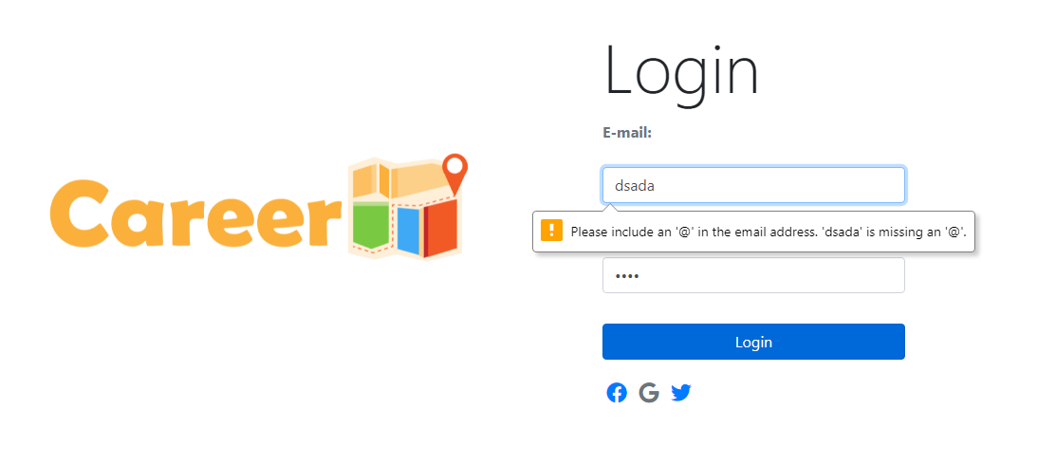



**Password validation checks:**





**Sign Up Form (with validation checks):**

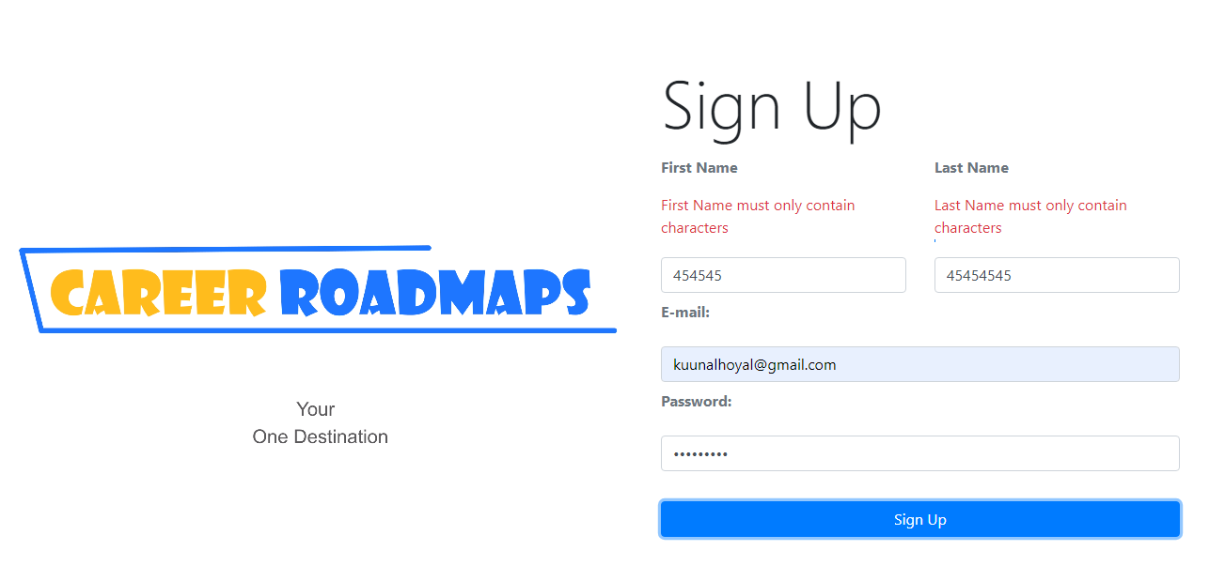

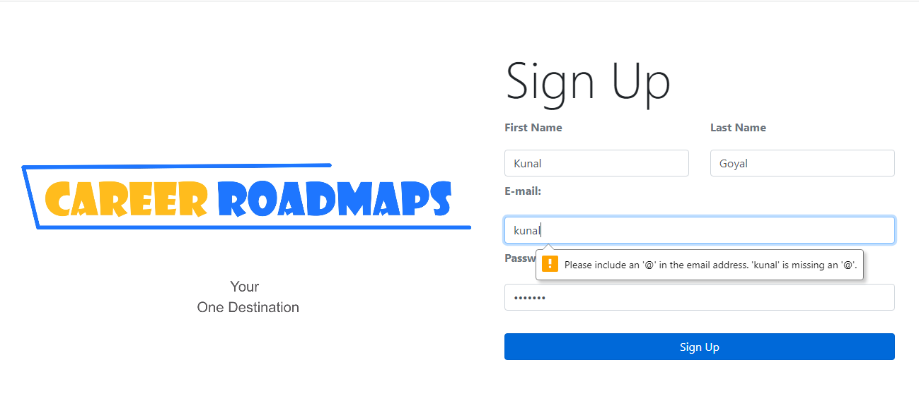

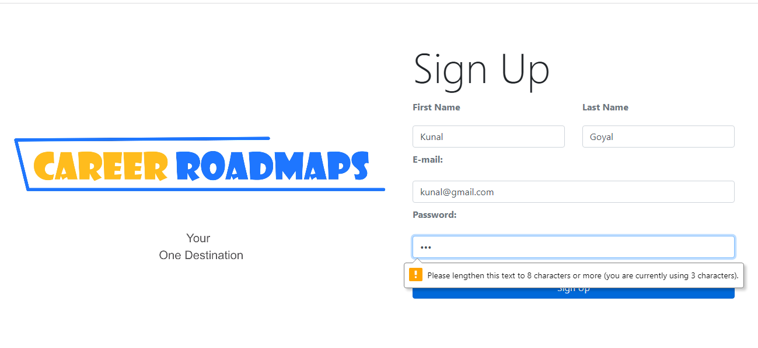

**Contact us Form Design (with validation checks):**

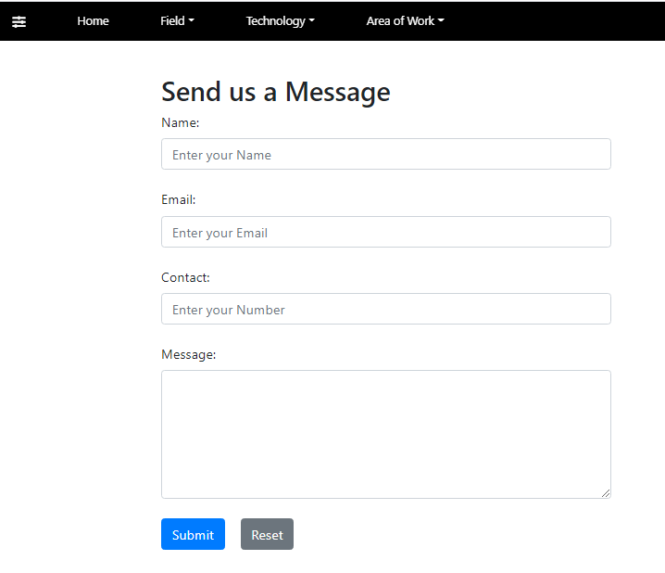

**Validation Rules for Name Field:**

1. **Name is a mandatory field it must be filled by the End-user else a validation message comes with a red mark (Please Enter a Name).**

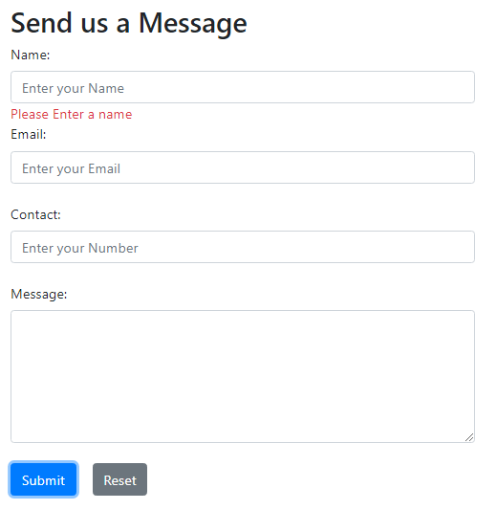

**2.Name must be in the range of 3-12 characters else a validation message is displayed (Name must be in the range of 3-12 characters)**

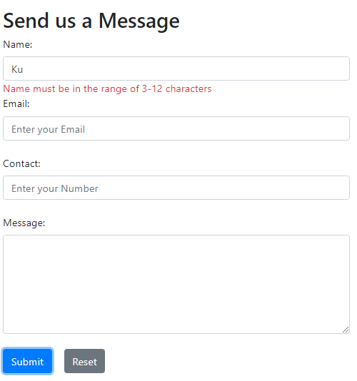

**3.Name field must only contain characters without any digits else a Validation message is displayed (Name must only contain characters)**

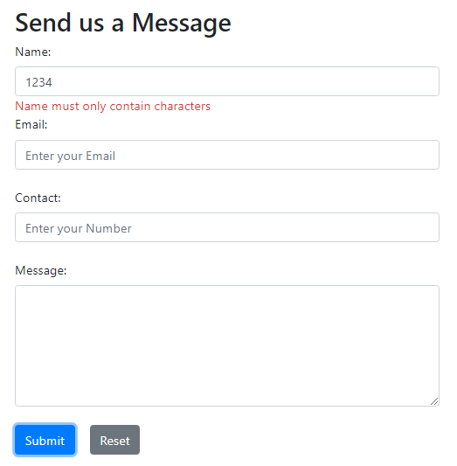

**Validation Rules for Email Field:**

**1. Email field is a mandatory field else an error validation message is displayed (Please Enter an Email)**

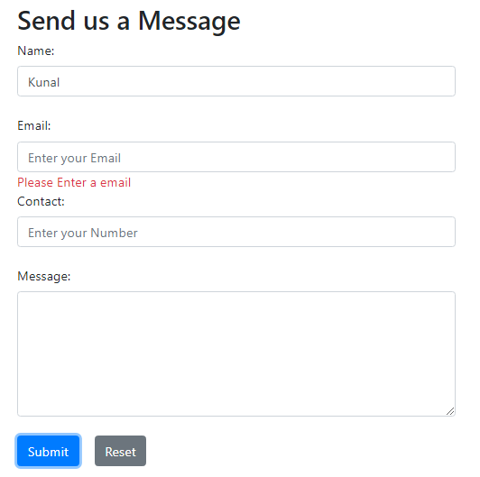

**2.Email entered by the end user must be a valid email and must consist of ‘@’ symbol and ‘domain-name.com’ else an error validation message is displayed (Invalid Mail).**

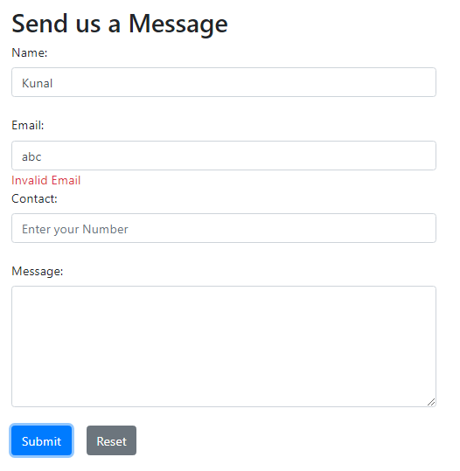

**Validation Rules for Contact Number Field**

**1.Contact Number is a mandatory field else an error validation message is displayed (Please enter a Contact Number)**

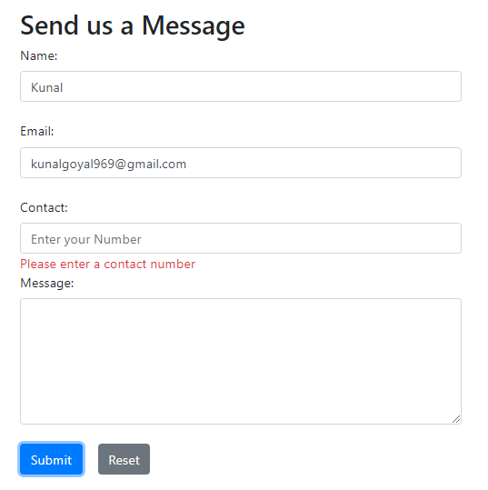

**2.Contact Number field must only contain digits and not characters else an error validation message is displayed (Contact must only contain Numbers).**

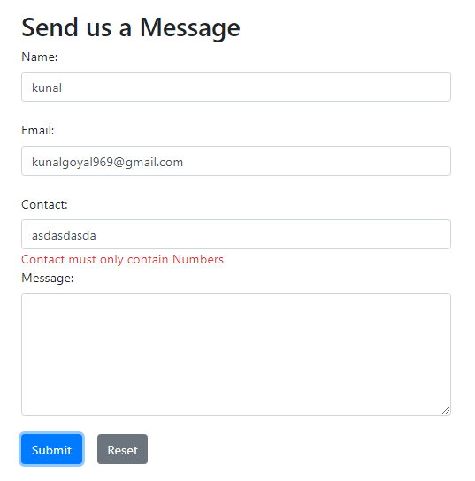

**3.Contact field must contain a contact number of 10 digits else an error validation message is displayed (Contact must be of 10 numbers).**

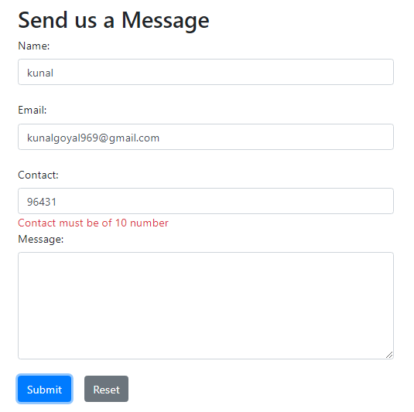

**Login Form (with validation checks) code:**

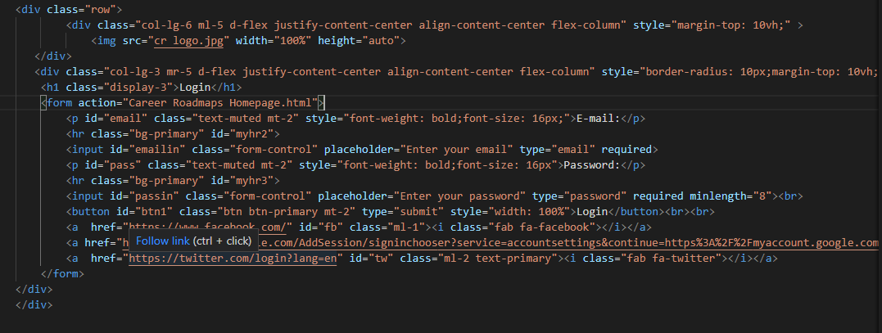

**Sign Up Form (with validation checks) code:**

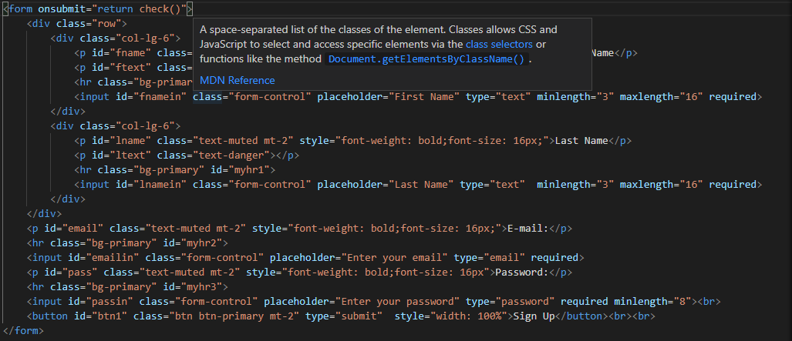

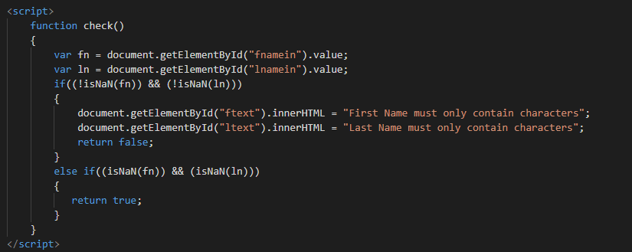

**Contact Us Form (with validation checks) code:**

